The University Of Azad Jammu & Kashmir

Student Name: Qurat Ul Ain Fatima
Roll No: 2024-SE-05
Course Title: Software construction & Development
Course Code: SE-3101
Course Instructor: Engr. Dr. Asma Javaid
Department: Software Engineering

LAB#05

Task 1: Create a GUI for User Login Page

Objective
Create a graphical user interface for a login page containing two fields: CNIC and Password. The login details will be checked using hardcoded values.

Step 1: Create a Windows Forms Project
- Open Visual Studio.
- Click on Create a New Project.
- Select Windows Forms App (C#).
- Enter the project name UserLogin.
- Click Create.

Step 2: Design the Login Form
Add the following controls from the Toolbox:
- Label – Set Text to CNIC.
- TextBox – Set Name to txtCNIC.
- Label – Set Text to Password.
- TextBox – Set Name to txtPassword.
- Button – Set Name to btnLogin and Text to Login.
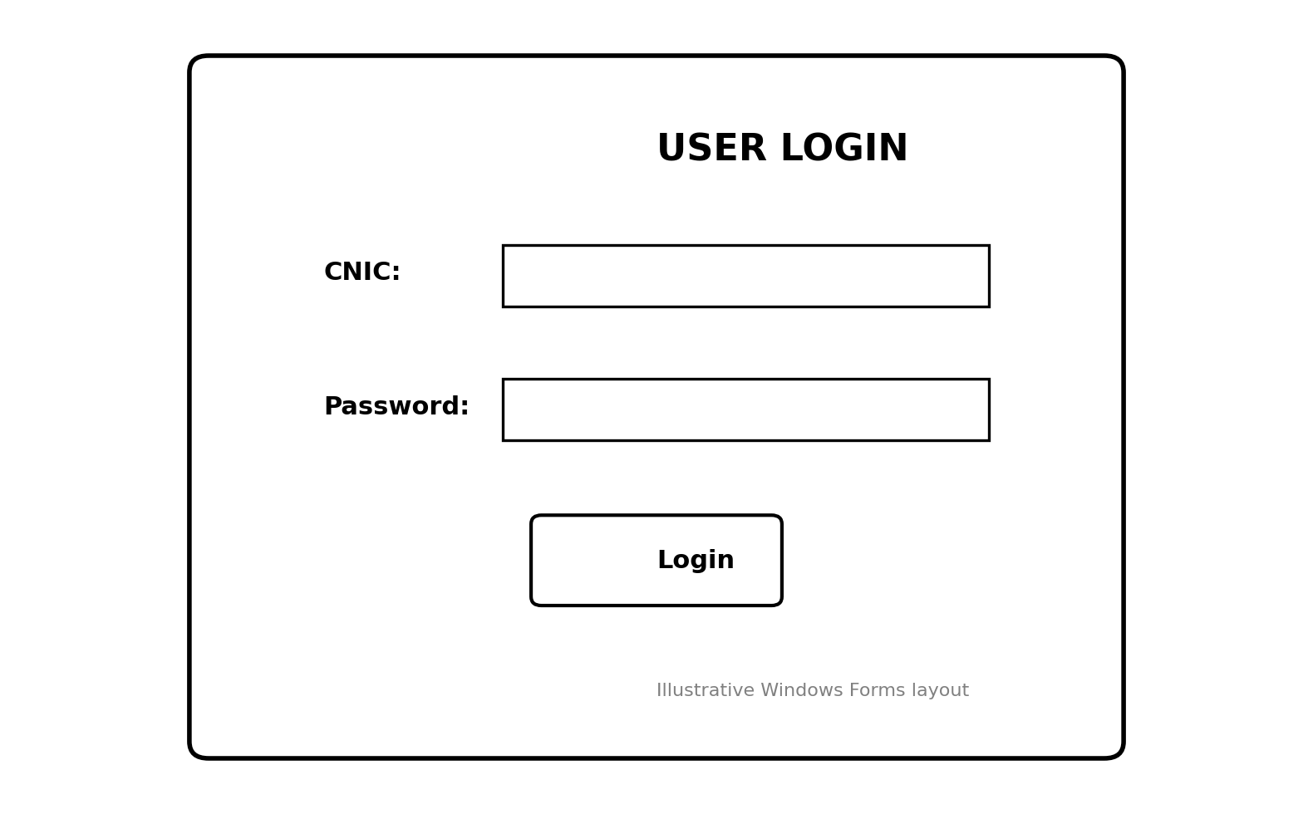

Step 3: Hide the Password
Select the Password TextBox and set:
- Name: txtPassword
- UseSystemPasswordChar: True
This hides the password while the user enters it.

Step 4: Write the Login Button Code
Double-click the Login button and write the following code:
private void btnLogin_Click(object sender, EventArgs e)
{
string cnic = txtCNIC.Text;
string password = txtPassword.Text;

if (cnic == "1234567890123" && password == "12345")
{
MessageBox.Show("Login Successful!");
}
else
{
MessageBox.Show("Invalid CNIC or Password!");
}
}
Note: These are sample hardcoded login credentials. You can change them as required.

Step 5: Run the Program
- Press F5 to run the application.
- Enter the sample CNIC: 1234567890123.
- Enter the sample Password: 12345.
- Click the Login button.
- A success message will appear if both values are correct. Otherwise, an error message will appear.

Result
A User Login Page is created with CNIC and Password fields and hardcoded validation.

Task 2: Create a GUI Information Form

Objective
Create a graphical user interface containing First Name, Last Name, Gender, Date of Birth, Hobbies, and a Submit button. Validate the required fields and display a welcome message.

Step 1: Create a Windows Forms Project
- Open Visual Studio.
- Create a new Windows Forms App (C#) project.
- Enter the project name UserInformationForm.
- Click Create.

Step 2: Add First Name and Last Name Fields
Add the following controls from the Toolbox:
First Name
- Label: First Name *
- TextBox Name: txtFirstName
Last Name
- Label: Last Name *
- TextBox Name: txtLastName
The asterisk (*) indicates that these fields are mandatory.

Step 3: Add Gender Radio Buttons
Add two RadioButtons:
- Name: rbMale
- Text: Male
- Name: rbFemale
- Text: Female
Set the Male RadioButton property:
- Checked: True
This makes Male selected by default.

Step 4: Add Date of Birth
- Drag a DateTimePicker from the Toolbox.
- Set its Name to dtpDOB.
- Set the minimum date to 1 October 1950.
- Set the maximum date to the current date.
- Set the default date to the current date.
You can configure these properties using the following code:
private void Form1_Load(object sender, EventArgs e)
{
dtpDOB.MinDate = new DateTime(1950, 10, 1);
dtpDOB.MaxDate = DateTime.Today;
dtpDOB.Value = DateTime.Today;

rbMale.Checked = true;
}

Step 5: Add Hobbies Checkboxes
Add five CheckBoxes with the following names and text:
- Name: chkCricket – Text: Playing Cricket
- Name: chkTV – Text: Watching TV
- Name: chkBooks – Text: Reading Books
- Name: chkMusic – Text: Listening Music
- Name: chkTravelling – Text: Travelling to New Places
The user can select one or more hobbies.

Step 6: Add Submit Button
- Drag a Button from the Toolbox.
- Set its Name to btnSubmit.
- Set its Text to Submit.
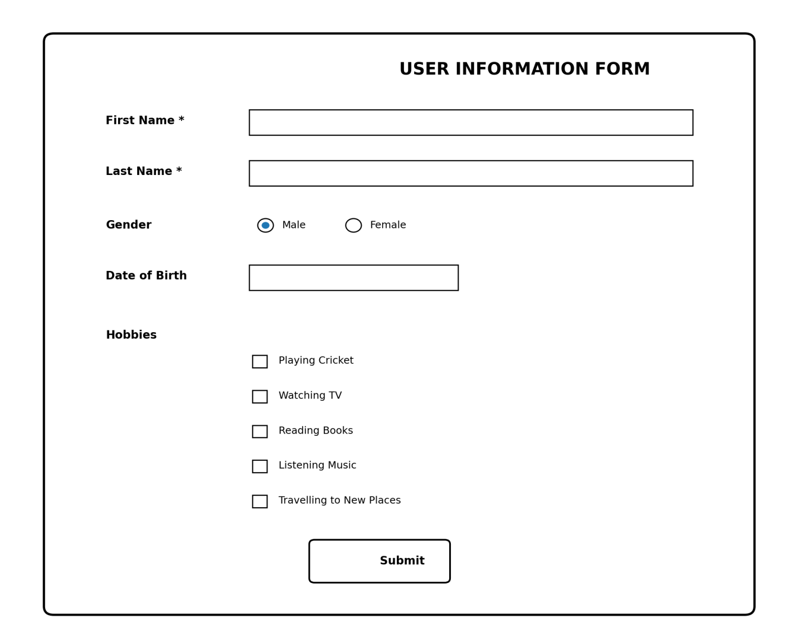

Step 7: Write the Submit Button Code
Double-click the Submit button and write the following code:
private void btnSubmit_Click(object sender, EventArgs e)
{
string firstName = txtFirstName.Text.Trim();
string lastName = txtLastName.Text.Trim();

if (firstName == "" || lastName == "")
{
MessageBox.Show("Please enter First Name and Last Name.");
return;
}

if (!rbMale.Checked && !rbFemale.Checked)
{
MessageBox.Show("Please select Gender.");
return;
}

MessageBox.Show(
"Welcome " + firstName + " " + lastName,
"Information",
MessageBoxButtons.OK,
MessageBoxIcon.Information
);
}

Step 8: Run the Program
- Press F5 to run the application.
- Enter First Name.
- Enter Last Name.
- Select Gender.
- Select Date of Birth.
- Select your hobbies.
- Click Submit.
- If the required fields are filled, an information message box will appear.

Expected Output
If the user enters:
- First Name: Ali
- Last Name: Ahmed
- Gender: Male
The following message will appear:
Welcome Ali Ahmed
The message box will display an information icon.

Result
A User Information Form is created with textboxes, radio buttons, a date picker, checkboxes, and a Submit button. Required fields are validated, and a welcome message is displayed after successful validation.

Final Conclusion
In this lab, two graphical user interfaces were created using C# Windows Forms.
- A User Login Page was created with CNIC and Password fields using hardcoded validation.
- A User Information Form was created with First Name, Last Name, Gender, Date of Birth, Hobbies, and Submit button. Required fields were validated, and a welcome message was displayed.

